**Promocode-Affiliated Marketing**

# Objective

The Promo Code component is currently available in the cart module. User can apply any valid promo code and get the benefits. When user apply the promo code, an api call happens which first verify the validity of promo code in terms of expire, category and delicacy. If it’s a valid promo code, it applied on cart.

Promo-code affiliation extends the above default behavior to performs below functions:

* Website landing Page: End user can land to website with promo code in URL.
* Empty Cart: Apply the promo code from URL to the empty cart.
* Cart with products: Apply promo-code automatically on the cart.

# Linked Components

1. **Linked Component: (cart-icon.component.tsx)**

The component will be displayed on the header for populating cart item count. It fills the cart information on first time load and update once user added any product into cart. As per our requirement, we must attach fetched query param promo code into cart information.



1. **Linked Component: (promocode.component.tsx)**

This component will be displayed when user click on cart icon or user added any product into cart. User comes with a promo code and click on apply button.

# Steps to consume the sample code.

Please follow below steps to consume the attached sample code to implement this feature.

1. Unzip the attached code and save it to some location.
2. **Header View Extension**: (*header.view.tsx*). Need to extend header view to add business logic to extract the query string parameter “promocode” from url and make a call to addPromocode callback method on cart by passing the promocode extracted from URL.

Check for this file under src/themes/”PartnerTheme”/views to make below code changes in this file.

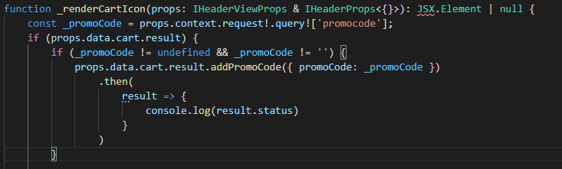

Below is the sample folder structure of theme folder.

**Note**: Here the name of theme folder depends on theme folder name in partner’s repository.

1. **Build the repository**:

Execute yarn build from command line interface on your repository after making the code changes.

1. **Testing:**

Execute yarn start and browse 4000 port with promocode query string parameter.

[https://localhost:4000?promocode=CPN0008](https://localhost:4000/citta/?promocode=CPN0008)

1. **CMS Changes:** NA